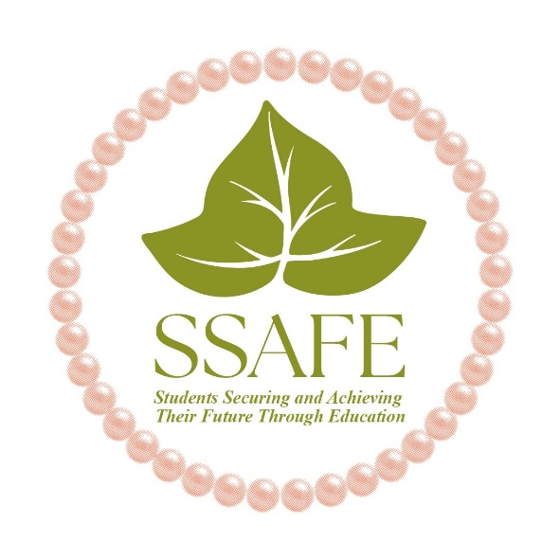

SCHOLARSHIP OPPORTUNITY
Students Securing and Achieving their Future through Education (SSAFE)

February 15, 2026

Subject: Scholarship Awards for African American Students

To: Students, Counselors, Career and College Center Technicians, and Community Members:

SSAFE will present its 18th Annual Scholarship awards this year. Recipients will be selected from applications submitted by African American students who meet the following criteria:

- A graduating high school senior (2025-2026 school year)
- Attends school in Ventura County
- Cumulative grade point average of 2.5 (C+) or above
- Must plan to attend a 2-year community college or a 4-year college/university

Students must submit:

A neatly completed scholarship application

One (1) official transcript in a sealed envelope

A one-page, typewritten, essay about yourself and future goals (50% of score)

A recent clear, color photo

Scholarship application packets sent electronically or mailed to the P. O. Box must be received by April 15, 2026.

Mail to: SSAFE
PO Box 7706
Oxnard, CA 93031

E-mail to:
ssafefoundation@gmail.com

Respectfully,
Letitia Austin
Letitia Austin
Scholarship Committee Chairperson

