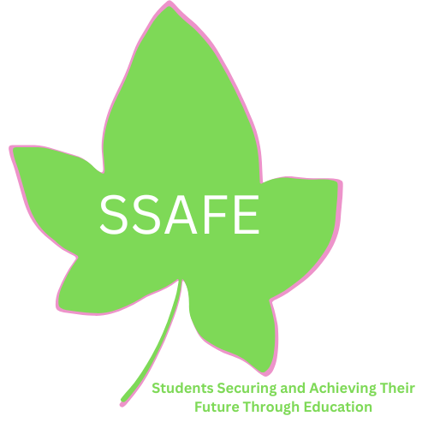

Students Securing and Achieving their Future through Education

February 25, 2024

Subject: Scholarship Awards for African American Students

To: Students, Counselors, Career and College Center Technicians, and Community Members:

SSAFE will present its 17th Annual Scholarship awards this year. Recipients will be selected from applications submitted by African American students who meet the following criteria:

- A graduating high school senior (2023-2024 school year)
- Attends school in Ventura County
- Cumulative grade point average of 2.5 (C+) or above
- Must plan to attend a 2-year community college or a 4-year college/university

Students must submit:

A neatly completed scholarship application

One (1) official transcript in a sealed envelope

A brief typewritten, essay about yourself and future goals (50% of score)

A recent photo

Scholarship application packets sent electronically or mailed to the P. O. Box must be received by April 13, 2024.

Mail to: SSAFE
PO Box 7706
Oxnard, CA 93031

E-mail to:
ssafefoundation@gmail.com

Respectfully,
Dondra Shephard
Dondra Shephard
President of SSAFE &
Director of Scholarships

